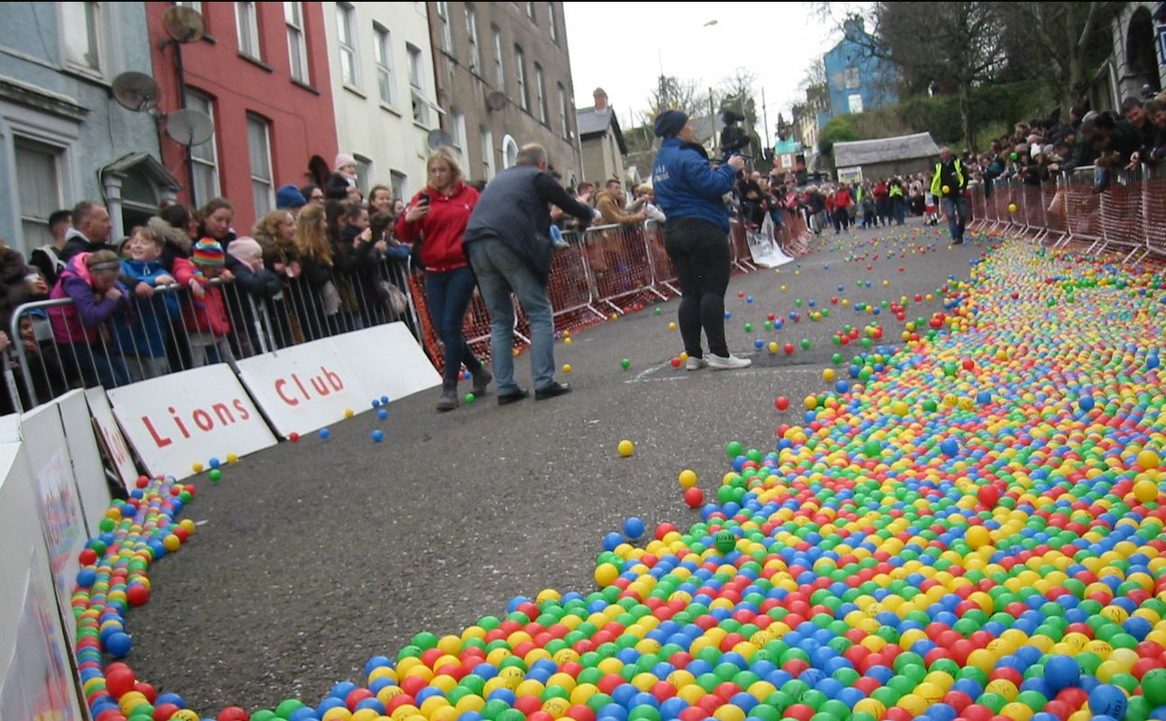  27TH arpil  charity ball drop  Fundraiser in aid of Irish Guide Dogs & school sports facilities.  This event is run by 5th year Link Modules students in St. Mac Dara’s Community College in Templeogue. We chose this as our enterprise project.  Our class will issue sponsor cards, each line gets the buyer a ball, the more balls you buy, the more chances to win!  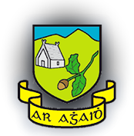 | ────  Amazing prizes to be won!  INCLUDING IPAD MINI  Hampers  Vouchers  and much more!  ────  Follow us on social media:  @smdballdrop @smdballdrop  ────  st mac dara’s c.c  Templeogue, Dublin 6W  01 456 6216  stmacdaras.ie  Date: 27th April  Time: TBC

