6th year Higher Options 2018/19
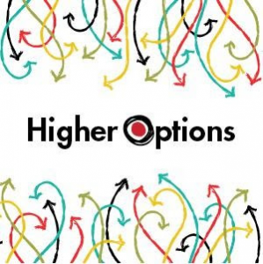
The 6th year Higher Options conference takes place on Wednesday 12th of September in the RDS Simmonscourt, Ballsbridge, Dublin 4 . Please see www.Higheroptions.ie for further details.
Higher Options is the largest and most comprehensive exhibition for Leaving Cert students who want to know what third level university and college options are available and how to apply for them. Exhibitors from Ireland, the UK, Europe, Australasia and the USA will attend.
Students must purchase tickets from the college online payments link on our college website https://eps.enrol.ie/stmacdaras/index.aspx before FRIDAY 25th MAY at the latest.

