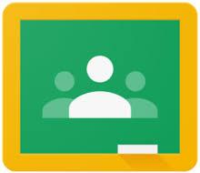
Parent Guide to Google Classroom

Google Classroom is an online platform where teachers can send your children work when away from school.

Accessing Google Classroom
Students can access Google Classroom using the mobile apps (Android and iOS), or via the web by visiting http://classroom.google.com
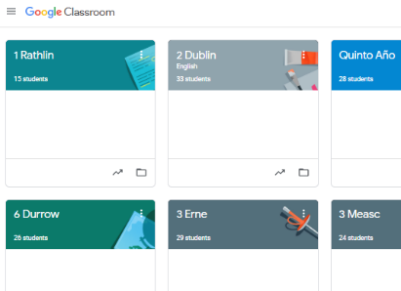
Students then log on using their school email and password.

Once students have logged in, they will see the class overview page. From here
they can see all of the classes they are registered with and
a summary of any work due.

Clicking on a class will open that Classroom.

Accessing resources
Clicking on a class will show the stream. Along the top you will see the tab ‘Classwork.’ This is where you can access the assignments given. The details of an assignment will be shown by clicking on the heading.

Children can then read the instructions and see any files attached to the assignment.
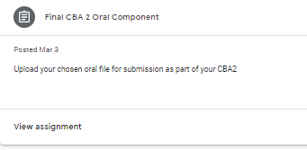

Submitting work online
The simplest way to complete the homework online is to open the attachment and complete the task as per teacher instruction, or do it on a Doc/Slide and attach it back to the assignment space.
When you are finished, you must click ‘add or create’ and attach your file. It is VITAL that you select ‘Turn in,’ otherwise your teacher will not receive your file.

Alternatively, the work can be completed in books or on paper and a photo can be uploaded as per the instructions above.

Teachers will detail how and when they would like the word returned in the task description

