3rd Year CBA Calendar 2023/2024

September/October 2023 | November/ December 2023/24
Graphics CBA 2: Graphical Presentation Skills  Mon 18th Sept – Fri 6th Oct  Wood Technology CBA 2: Student Self Analysis and Evaluation  Mon 18th Sept – Fri 6th Oct  Engineering CBA 2: Research and Development  Mon 18th Sept – Fri 6th Oct | Visual Art CBA 2: Communicate and Reflect (10 Weeks)  Mon 4th Sept – Fri 17th Nov
January 2024 | Feb/March 2024
Gaeilge CBA 2: Communication Task  Mon 8th Jan – Fri 26th Jan  MOCKS | Music CBA 2: Programme Note (3 Weeks)  Mon 19th Feb - Fri 8th March  Home Economics CBA 2: Food Literacy Skills Brief  Mon 19th Feb - Fri 8th March
 | Reminders:
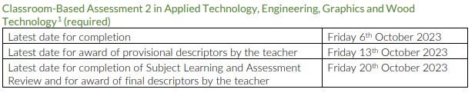  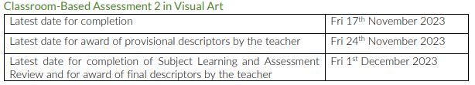  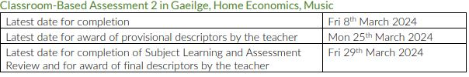 | -SLAR meetings must be held within one month of CBA completion.  -Grade descriptors must be inputted to VSware one week after SLAR is completed.  -SLAR Facilitator Reports must be saved in the folder called SLAR Reports 23-24 on Sharepoint. This is found in the Documents section of the St MacDaras group.

