Foireann for Parents/Students:
With your Child's school using Foireann to manage some aspects of the Gaelic Games activities, provided by the school, it's essential that you know what you need to do to ensure you, and the school, get the most out of Foireann.
One of several benefits of Foireann is that no matter what ways you - or a son, daughter or other dependents - are involved with Gaelic games, one Foireann account will allow you to manage all of your interactions. This means that anyone already using Foireann has to add the school to their profile, as well as your child's profile(s).
Regardless of your level of existing Foireann knowledge, the following FAQ’s should answer many of the questions you are likely to have as you start using Foireann with your child's school...

Q: I have a Foireann account already, how do I get my son/daughter’s school set up?
To add a School to your - and your Child's existing profile - you simply need to follow the exact same process as you would have when you previously added a Club(s) to those same profiles...
1. First access your Profile via the main navigation menu on the left-hand side of the screen
2. Scroll to the bottom of your profile page where any existing Clubs or Counties are listed.
3. Click on the "Add Club" button and then from the dropdown menus that appear, set...
- Your Association as "School"
- County Board to the county your School is located
- Club to the School name which you can scroll or type to find the name.
4. Once you have added your School to your profile, simply click the "Save" button to complete the update of your profile

It's really important you follow these same steps on your Child's profile, accessible via the Family section of Foireann, as well as your own so you can interact on Foireann, on their behalf, with their school.

Q: I have a Foireann account, but my son/daughter doesn’t, what do I do?
1. Navigate to the 'Family' section of the app, via the .
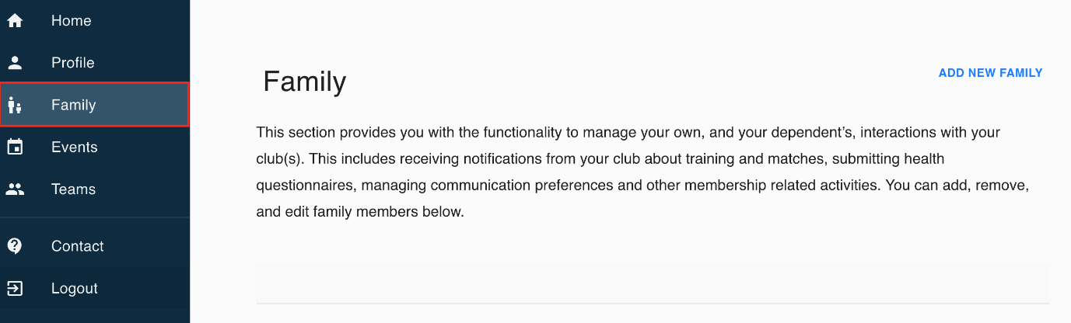
2. Click the ‘Add New Family’ button.
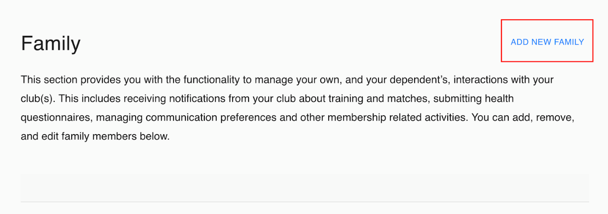
3. Give your Family group a ‘Name’, likely the family name or surname, and if you want to, you can also give it a ‘Description’.
4. Once you are happy with all the details, click the ‘Confirm’ button to complete the creation of your Family group.
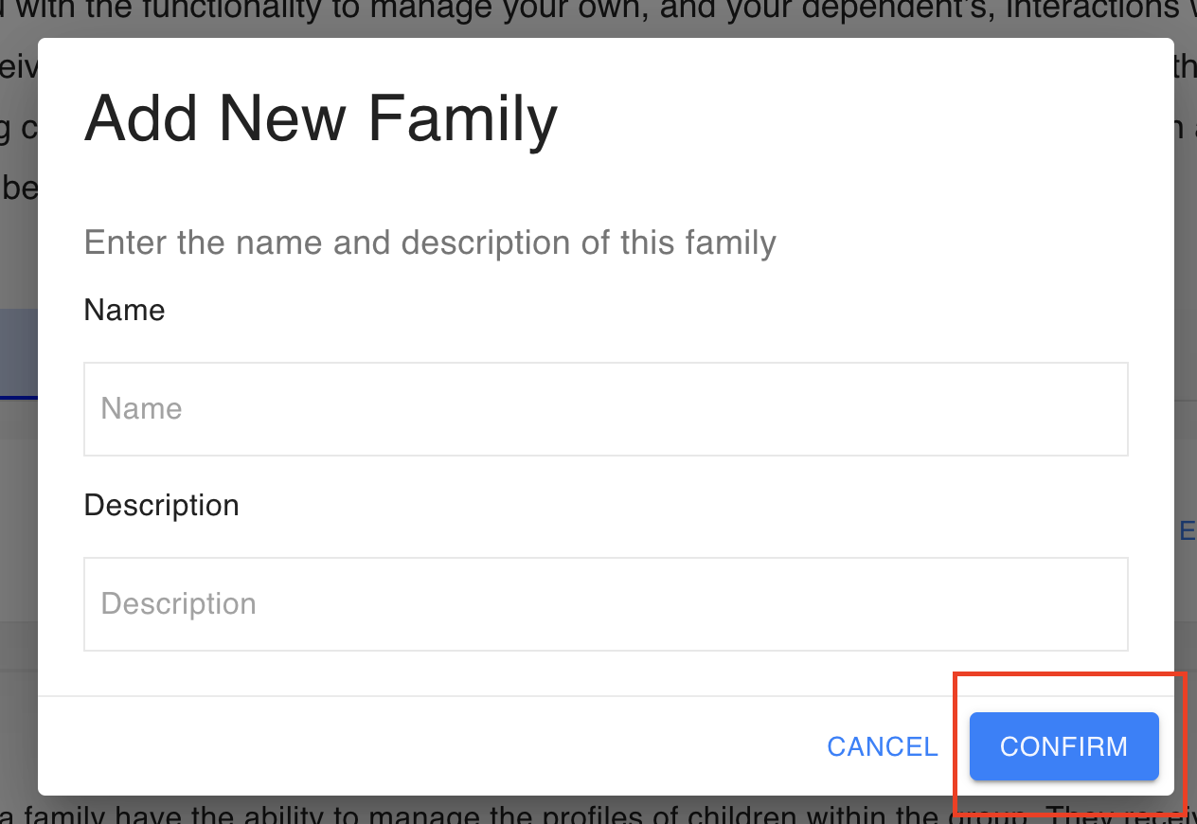

Now that you have your Family set up, you need to add everyone that should be included in it such as:
- Additional Parents/Guardians
- Children
- Additional People
The main Family section of the Foireann Help Centre provides more detail about inviting Parents/Guardians, Adding Children or inviting Additional People to your Foireann Family group but the basic steps required to add Children to your Family group are below...

1. Scroll down to the Children section of your new Family group and click the ‘Add Child’ button
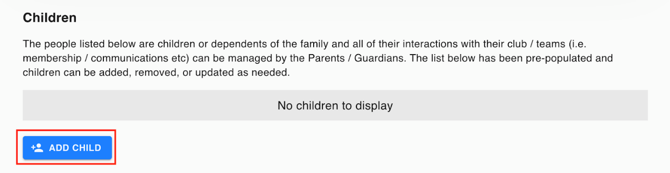
2. In the pop-up window that appears, add the Child's First Name and Surname and then click on the 'Confirm' button.
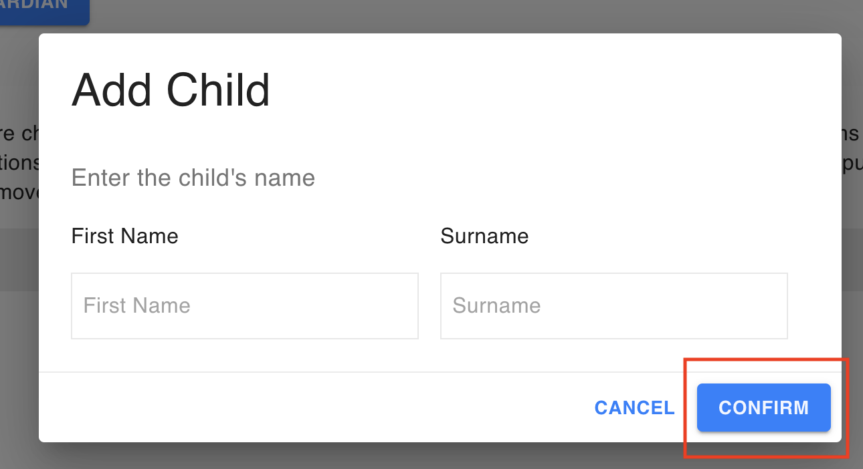
You will now see your Child listed within the Children section of your Family, with an amber warning aginst their name, highlighting that their profile still needs to be completed, which can only be done by a Parent/Guardian.
3. Click on 'Edit' to open the newly created Profile for your Child that will be capture the exact same information as your own profile, with two important changes:
Anyone under the age of 18 isn't permitted to have a username and password for Foireann, with a Parent/Guardian being responsible for managing a profile on behalf of a juvenile. This means there is no username or email options on a Child's profile.
4. Just as for your own Profile, add your Chidl's school to the Clubs section of their profile by clicking on the 'Add Club' button and then from the dropdown menus that appear, set...
- Their Association as "School"
- County Board to the county your School is located
- Club to the School name which you can scroll or type to find the name of.
4. Once you have added their School to their profile, simply click the "Save" button to complete the their profile.

Q: Foireann is brand new to me and my child, what do I need to do?
1. Navigate to Foireann.ie and click on the "Register" link on the login window
2. Enter the relevant information into each of the form fields and click the continue button
3. Before completing your account setup, you will need to verify your email address by clicking on the link in the email sent to the address provided in step 2.
4. After verifying your email, you will then be redirected back to Foireann where you will see your profile page which is, at this stage, still incomplete.
5. All you need to do here is work through your profile page, from top to bottom, filling in all the details you are happy to provide
6. The last, and possibly most important thing you need to do on your profile is add the relevant 'Club' or in your case, School. To do this, click on the "Add Club" button and then from the dropdown menus that appear, set...
- Your Association as "School"
- County Board to the county your School is located
- Club to the School name which you can scroll or type to find the name of.
7. Once you have added your School to your profile, simply click the "Save" button to complete the account and profile creation process.

Now you have your own account created, you need to add your Children to Foireann and you use the Family section of the App to do this...

1. Navigate to the 'Family' section of the app, via the .
2. Click the ‘Add New Family’ button.
3. Give your Family group a‘Name’,likely the family name or surname, and if you want to, you can also give it a‘Description’.
4. Once you are happy with all the details, click the ‘Confirm’ button to complete the creation of your Family group.

Now that you have your Family set up, you need to add everyone that should be included in it such as:
- Additional Parents/Guardians
- Children
- Additional People
The main Family section of the Foireann Help Centre provides more detail about invitingParents/Guardians,Adding Childrenor invitingAdditional Peopleto your Foireann Family group but the basic steps required to add Children to your Family group are below...

1. Scroll down to the Children section of your new Family group and click the ‘Add Child’ button
2. In the pop-up window that appears, add the Child's First Name and Surname and then click on the 'Confirm' button.
You will now see your Child listed within the Children section of your Family, with an amber warning aginst their name, highlighting that their profile still needs to be completed, which can only be done by a Parent/Guardian.
3. Click on 'Edit' to open the newly created Profile for your Child that will be capture the exact same information as your own profile, with two important changes:
Anyone under the age of 18 isn't permitted to have a username and password for Foireann, with a Parent/Guardian being responsible for managing a profile on behalf of a juvenile. This means there is no username or email options on a Child's profile.
4. Just as for your own Profile, add your Chidl's school to the Clubs section of their profile by clicking on the 'Add Club' buttonand then from the dropdown menus that appear, set...
- Their Association as "School"
- County Board to the county your School is located
- Club to the School name which you can scroll or type to find the name of.
4. Once you have added their School to their profile, simply click the "Save" button to complete the their profile.

